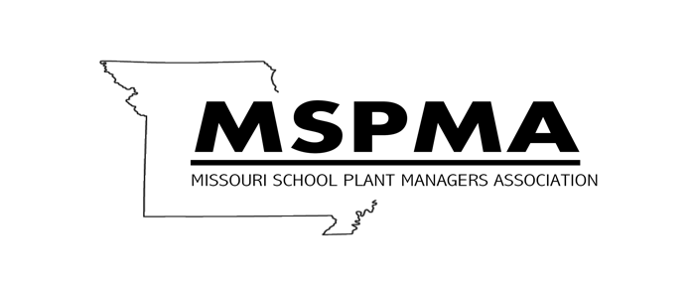

FACILITIES MANAGER CORE CERTIFICATION
Registration Form 2020
Name: _______________________________________________________________________

Date: ________________________________________________________________________

School District:________________________________________________________________

Street Address________________________________________________________________

City:_________________________State:______________________-Zip:_________________

Telephone:___________________________Fax: ____________________________________

Email:________________________________________________________________________

Core Certification consists of 7 modules totaling 32 hours of training. First module
(Introduction)was offered at the MSPMA Conference September 28-30, 2014 and will not be offered again, instead you will receive introduction on a USB at first training site attended. Two additional modules will be offered at various sites around the state in 2020. Check website for dates and location.
Cost $60.00 per module or a one-time cost of $350.00 for all modules

Members must be a member in good standing:
MSPMA membership cost is $100.00 per year*
Example: One time cost for all Certification Training………………………….…..$350.00 MSPMA
Yearly Membership……………………..….…………………………….………..$100.00*
Total…$450.00

Cost per single Module…(Identify Module #)………..………………………..…..…$60.00
MSPMA Yearly Membership…….…………………………………………..……………….$100.00*
Total……….$160.00
Make checks or purchase orders to MSPMA and mail to:
Charley Branham
308 Evergreen Court
Troy, Missouri 63379

